DAY 2

DDL - stands for Data Definition Language. (Database)
Create
Alter
Drop
Truncate
Rename

DML - stands for Data Manipulation Language. (Table)
Select
Insert
Update
Delete

\dt - Display tables
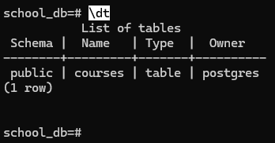

drop table courses; - Drop table
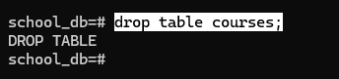

select * from courses; - Select table
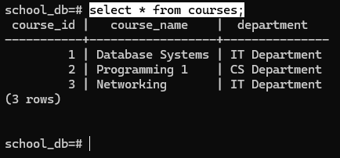

delete from courses where course_id = 3;

select * from courses where course/-id = 1; - To filter on the tables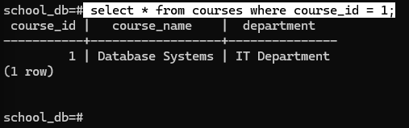

select course_name from courses where department = ‘IT Department’;
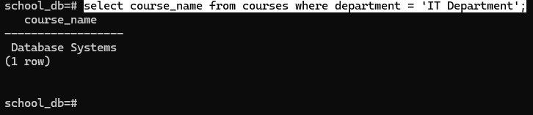

insert into courses(course_name, department) values
(‘Networking’,’IT Department’);
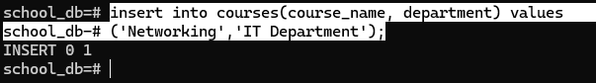

Data Type

\d courses
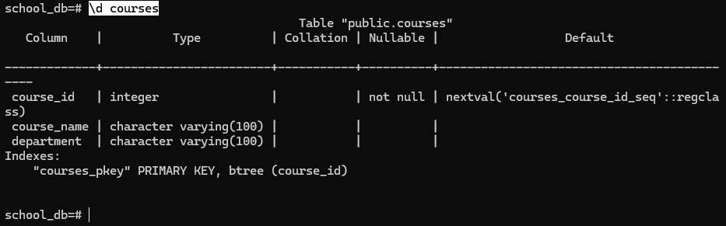

update courses set course_id = 3 where course_name like ‘%Net%’;

update courses set course_name = ‘Programming’ where course_id = 2;
select * from courses order by course_id asc;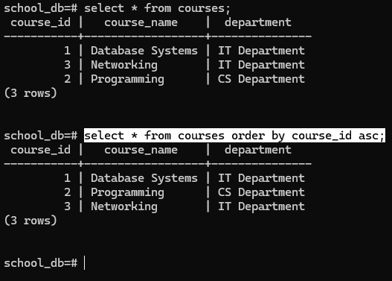

alter table courses
add constraint chk_course_name_letters
check (course_name ~ '^[A-Za-z ]+$');
